Takeovers Panel
Annual Report 2024–25

© Commonwealth of Australia 2025
ISSN 2204-0854 (Print)
ISSN 2204-0862 (Online)
This publication is available for your use under a Creative Commons Attribution 4.0 International licence, with the exception of the Commonwealth Coat of Arms, the Takeovers Panel logo, photographs, images, third party materials, materials protected by a trademark, signatures and where otherwise stated. The full licence terms are available from creativecommons.org/licenses/by/4.0/legalcode.
Use of Takeovers Panel material under a Creative Commons Attribution 4.0 International licence requires you to attribute the work (but not in any way that suggests that the Treasury or the Takeovers Panel endorses you or your use of the work).
Takeovers Panel material used ‘as supplied’
Provided you have not modified or transformed Takeovers Panel material in any way including, for example, by changing the Takeovers Panel text; calculating percentage changes; graphing or charting data; or deriving new statistics from published Takeovers Panel statistics – then the Takeovers Panel prefers the following attribution:
Source: The Commonwealth of Australia.
Derivative material
If you have modified or transformed Takeovers Panel material, or derived new material from those of the Takeovers Panel in any way, then the Takeovers Panel prefers the following attribution:
Based on Commonwealth of Australia data.
Use of the Coat of Arms
The terms under which the Coat of Arms can be used are set out on the Department of the Prime Minister and Cabinet website
(see pmc.gov.au/honours-and-symbols/commonwealth-coat-arms).
A copy of this document appears on the Takeovers Panel website. The website address is takeovers.gov.au.
Printed by CanPrint Communications Pty Limited.

 | Level 16, 530 Collins Street  Melbourne VIC 3000
 | Telephone:  Internet:  Email: | 03 9655 3500  www.takeovers.gov.au  takeovers@takeovers.gov.au

23 September 2025

The Hon Dr Andrew Leigh MP
Assistant Minister for Productivity, Competition, Charities and Treasury
Parliament House
Canberra ACT 2600
Dear Assistant Minister
ANNUAL REPORT 2024–25
In accordance with section 183 of the Australian Securities and Investments Commission Act 2001, I submit the 2024–25 Annual Report of the Takeovers Panel for presentation to Parliament.
Yours sincerely

Alex Cartel
President

Table of Contents
List of Tables vi
List of Charts vi
Index of Compliance vii
Part 1 – Background 1
Who we are 1
Our website 2
Who to contact 2
Review by the President 3
Panel at a glance 2024–25 6
Part 2 – The Panel 7
Other features 8
Organisational structure 9
Panel President 9
Acting Presidents 10
Panel executive 10
Office 11
Appointment of Panel members 12
Members’ biographies 15
Part 3 – The Work of the Panel 19
Matters 19
Issues in applications 21
Ensuring consistency 22
Guidance 22
Consultation 22
Legislation 22
Judicial review 23
Part 4 – Performance Reporting 25
Matter reviews 25
Industry liaison 25
Referrals to ASIC 25
Website 26
Announcements and media releases 26
Corporate governance 26
Outcome and output information 26
Financial information 28

Part 5 – Management and Accountability 31
External scrutiny 31
Management of human resources 31
Purchasing 34
Consultants 34
Small business 34
Discretionary grants 34
Advertising and market research 34
Environmental performance 34
Freedom of information 35
Impact analysis 35
Appendix 1 – Panel members 36
Appendix 2 – Sub-committee members 38
Appendix 3 – Panel applications 40
Appendix 4 – Abbreviations and acronyms 45
Index 46

List of Tables
Table 1: The Panel’s dispute resolution functions 7
Table 2: Appointment of Panel members during 2024–25 12
Table 3: Outcome of applications received by the Panel, 2024–25 20
Table 4: Time to decision by the Panel, 2024–25 21
Table 5: Issues raised in applications, 2024–25 21
Table 6: Summary resource statement 27
Table 7: Income statement (Showing Net Cost of Services) (unaudited) for the period ended 30 June 2025 28
Table 8: Operative staff by classification and gender 32
Table 9: Members of the Panel at 30 June 2025 36
Table 10: Members appointed to the Panel in 2024–25 37
Table 11: Members who ceased their membership of the Panel in 2024–25 37
Table 12: Sub-committees 38
Table 13: Applications received by the Panel in 2024–25 40
Table 14: Outcomes of review applications received by the Panel in 2024–‍‌25 44

List of Charts
Chart 1: The Panel’s organisation structure as at 30 June 2025 9
Chart 2: Panel members by profession at 30 June 2025 13
Chart 3: Panel members by location at 30 June 2025 13
Chart 4: Panel members by gender at 30 June 2025 14
Chart 5: The Panel’s process for applications for declarations of unacceptable circumstances 19

Index of Compliance
Letter of transmittal iii
Aids to access
Table of contents iv
Alphabetical index 46
Abbreviations and acronyms 45
Contact 2
Website 2

Review by the President
Review by the President 3
Overview of the Panel
Role and functions 7
Organisational structure 9
Performance reporting
Resources 27
Management and accountability
Corporate governance 26
External scrutiny 31
Management of human resources 31
Purchasing 34
Consultants 34
Small business 34
Financial performance and statements 28
Executive remuneration 32
Advertising and market research 34
Discretionary grants 34
Disability 33
Freedom of information 35
Impact analysis 35

Part 1 – Background

Who we are
The Takeovers Panel is a peer review body established as ‘a specialist body largely comprised of takeover experts’ that is the main forum for resolving disputes in takeovers. It consists at 30 June 2025 of 52 specialists in mergers and acquisitions – investment bankers, lawyers, company directors and other professionals.
The Panel, established in January 1991, underwent changes to its structure and role in March 2000. It operates under:
- Part 6.10 of the Corporations Act 2001 (Cth) (Corporations Act)
- Part 10 of the Australian Securities and Investments Commission Act 2001 (Cth) (ASIC Act)
- Part 3 of the Australian Securities and Investments Commission Regulations 2001 (Cth) (ASIC Regulations).

Our website
The Panel’s website (takeovers.gov.au) includes:
- media releases
- reasons for decisions and an index of decisions
- a description of the Panel and its operations and a guide to the takeover provisions in the Corporations Act
- Guidance Notes
- consultation papers
- Procedural Rules
- privacy policy
- annual reports
- legislative resources and other background material relating to mergers and acquisitions
- the Panel’s Agency Plan for the Information Publication Scheme.
Interested persons may subscribe to the Panel’s website to be notified when new items are posted.

Who to contact
Enquiries regarding this report may be directed to:
Mr Allan Bulman
Chief Executive, Takeovers Panel
Level 16, 530 Collins Street
Melbourne VIC 3000
Telephone: +61 3 9655 3500
Email: takeovers@takeovers.gov.au


Review by the President
The Panel experienced a very uneven workload in the 2024–25 financial year, similar to the previous financial year. Notably, there was a surge in the Panel’s workload during the second half of the financial year with 26 applications having been received (almost as many applications as the historical annual average).
It is a testament to the commitment and professionalism of the Panel members and executive that we were able to again cope with the peaks in workload this year, and that the average number of calendar days from receipt of application to decision (20.5 days) remained in line with the historical average (17.9 days).
Mr Alex Cartel
President of the Panel
With the higher than average number of applications over the past two years, a focus of the Panel has been to ensure that matters which need to be dealt with urgently are given appropriate attention. Given this focus, I was pleased to see that Dropsuite Limited, where the Panel made a declaration of unacceptable circumstances and orders, was completed in 18 days. As the Panel observed in its reasons for decision, this was assisted by succinct submissions from the parties and their advisers during the proceedings.
The Panel declined to conduct proceedings in relation to 20 of the 35 applications received in the 2024–25 financial year; a higher proportion than usual. The Panel declined to conduct proceedings in relation to all but one of the 15 applications involving allegations of association. Noting the complexity of this area, the Panel is considering whether it would be appropriate to issue a guidance note on association and I am in the process of convening a Panel sub-committee for this purpose.
Several matters received this year were at the boundaries of the Panel’s jurisdiction. For example, the Panel was asked to consider issues relating to share placements (Emu NL, Mayfield Childcare Limited, FBR Ltd), proposed delistings (Vmoto Limited, Pact Group Holdings Ltd 02 & 03), and allegations concerning a proprietary limited company and whether it had fewer than 50 members (Invest Blue Pty Ltd). In a number of these matters, it appeared that there may have been a misunderstanding as to the Panel’s remit. In addition, some applications raised issues which were either concurrently before the court or may have been more appropriately ventilated in court. The Panel’s main power to deal with applications which raise issues outside its remit is to decline to conduct proceedings. Where appropriate, it may direct that an amended application be provided before being considered. The Panel is also considering whether further guidance is needed in relation to its jurisdiction (for example, by way of an amendment to Guidance Note 1: Unacceptable Circumstances). I encourage applicants to consider seeking legal advice prior to submitting an application. As observed by the Panel in Pinnacle VRB Ltd 08 back in 2001, the Panel is intended to be a first-rate commercial Panel, not a second-rate court.
The Panel continues to experience disruptive behaviour from parties in some matters, including failures to answer questions in briefs. To that end, the Panel has been considering ways to address these issues and will be consulting publicly on proposed changes to Guidance Note 4: Remedies General which (among other things) provide further guidance on the circumstances in which the Panel will consider making costs orders against parties.
Off the back of the Metallica Minerals Limited and Westgold Resources Limited Panel matters last year, the Panel also discussed whether any guidance should be considered in relation to standstills. The Panel does not propose to issue any such guidance at present, but will continue to monitor this area.
I also convened Panel sub-committees this year in relation to merger reform and beneficial ownership to provide submissions to Treasury on those law reform initiatives.
The Panel recognises the importance of ASIC as a co-regulator in relation to takeovers and its role in the enforcement of the takeovers provisions and substantial holder provisions. The Panel welcomes submissions and other contributions from ASIC on Panel matters. The Panel also utilises its power to refer matters to ASIC in appropriate cases and is considering doing so more often. The Panel referred one matter to ASIC in 2024‍–‍25.
The Panel members, executive and I were saddened to hear that George Durbridge passed away in November 2024. George was the first General Counsel of the Panel from 2000 to 2007 and was instrumental in setting up the revitalised Panel. The Australian legal and regulatory community was a significant beneficiary of George’s extraordinary knowledge and wisdom.
As at 30 June 2025, the Panel had 52 part-time members. In March this year the government reappointed 14 Panel members and appointed 4 new Panel members. At the same time, 4 experienced Panel members’ terms ended—namely Mr Robin Bishop, Ms Elizabeth Hallett, Ms Denise McComish and Ms Kerry Morrow. I was reappointed as President and member of the Panel. I thank the Panel members for all their work throughout the year as participants in sitting Panels, at Panel days, on policy sub-committees and on post-matter reviews. I extend particular thanks to the outgoing Panel members for their excellent contributions to the Panel.
As announced in the Panel’s media release of 28 August 2025, the Panel has launched a new automated version of the Index of Reasons (a topic and legislation index of the Panel’s reasons for decisions) on its website. The Index of Reasons has also been updated to include reasons published from 1 March 2000 to 30 June 2025 and the new format will have the capacity to be updated more frequently. This is a very useful resource provided by the Panel to assist parties and the public and I encourage everyone to use it. I would like to thank Tania Mattei, Andrew Bubniw, Rebecca Andrewartha and the rest of the Panel executive for all their work in implementing this upgrade along with the Treasury Digital Delivery Team and digital specialists Webplace.
The Panel members and I greatly appreciate the support of the executive, who have worked tirelessly during this busy period. I would also like to thank Alan Shaw and Bruce Dyer for their assistance.
The Panel continues to be grateful to the Australian Government and the Department of the Treasury for their commitment to a robust, principles-based Panel regime and for their ongoing support.
I am pleased to report on our performance for the 2024–25 financial year.
Alex Cartel
President

Panel at a glance 2024–25
Applications received  (average 28.4 per year since 1 July 2000) |  |  | 35
Matters in which the Panel conducted proceedings  (average 54.88% since 1 July 2000) |  |  | 31.43%
Matters in which the Panel accepted undertakings¹⁰ |  |  | 2
Matters in which the Panel made declarations and orders¹⁰ |  |  | 3
Average calendar days between application and decision  (average 17.9 since 1 July 2000) |  |  | 20.5
Average calendar days between decision and publication of reasons,  (average 34.9 since 1 July 2000) |  |  | 38.5

Part 2 – The Panel
The Panel improves the certainty, efficiency and fairness of Australia’s takeovers market by:
- resolving disputes in a fair, timely, consistent, informal and sound manner
- publishing clear, well-developed guidance.
The Panel’s two main dispute resolution functions are considering whether unacceptable circumstances exist and reviewing certain decisions of ASIC.
Table 1: The Panel’s dispute resolution functions
 | Unacceptable circumstances | Review of ASIC decisions
What | Deciding applications for a declaration of unacceptable circumstances is the main work of the Panel | The Panel may, on application, review ASIC decisions under Chapter 6 and, during a takeover bid, Chapter 6C
How | The Panel (comprising three members) considers the circumstances against the principles in section 602, the provisions and policy of Chapter 6 and the public interest | The Panel may exercise all the powers of ASIC under Chapters 6 and 6C
Guidance | Guidance Notes, Procedural Rules, legislative policy of Chapter 6, previous decisions | Regulatory Guides, ASIC policies, reasons for ASIC’s decision, Panel policy
Table 1: The Panel’s dispute resolution functions (continued)
 | Unacceptable circumstances | Review of ASIC decisions
Outcomes | If a declaration is made the Panel can make any orders to address the unacceptable circumstances, including a ‘remedial order’ | Affirm, vary, set aside (and substitute/remit) the ASIC decision
Review | The Panel, on application, conducts a merits review of a decision of the initial Panel. A review Panel comprises three different members to the initial Panel. There may be only one review of a Panel decision | As the Panel proceeding is the merits review, there is no review Panel
How often | In the current period there were 29 applications for a declaration at first instance and 6 applications for review | In the current period there were no applications for review of an ASIC decision

Other features
The Panel may make rules, not inconsistent with the Corporations Act or the Corporations Regulations, to clarify or supplement the operation of the provisions of Chapter 6. It has not made any rules under this power.
The Panel has a power to make Procedural Rules. It published revised Procedural Rules in 2021.
The Panel may decide a matter referred from the Court. There were no referrals in the current period.

Organisational structure
Chart 1: The Panel’s organisation structure as at 30 June 2025
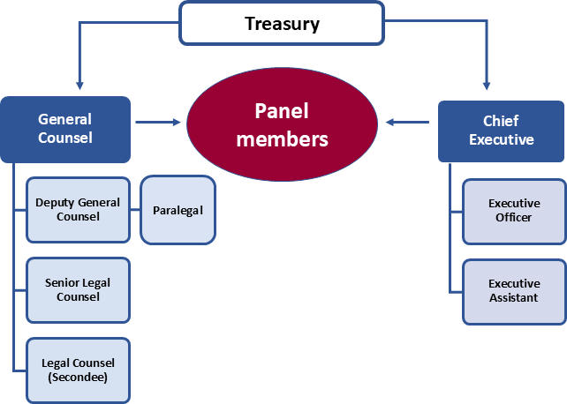

Panel President
Mr Alex Cartel, a member of the Panel, is its President. His responsibilities include:
- liaising with the Minister, Government, Treasury and stakeholders
- appointing members to constitute sitting Panels
- considering the interests of sitting Panel members for possible conflicts
- participating in reviewing the performance of the executive.
He regularly sits on matters.

Acting Presidents
The following members have been appointed to act as President when the President cannot act:
- Ms Yasmin Allen AM
- Mr Michael Lishman
- Ms Michelle Jablko
- Ms Diana Nicholson
- Mr Christian Johnston
- Ms Teresa Dyson.

Panel executive
The executive assists Panel members to make consistent, timely and commercial decisions. It provides:
- administrative and legal support for Panel members
- communication with parties in proceedings
- liaison with market practitioners, ASIC’s takeovers staff and ASX
- an interface to prospective parties (for example, discussing issues and providing a perspective on takeovers policy as it may apply to current takeovers).
During the financial year the Panel executive comprised:
- Chief Executive, Mr Allan Bulman
- General Counsel, Ms Tania Mattei
- Deputy General Counsel, Ms Katrina Fong (on long term leave)
- Deputy General Counsel, Mr Andrew Bubniw
- Senior Legal Counsel, Ms Melanie Gilbert
- Legal Counsel, secondees. The Panel’s normal process is to staff its office, in part, with secondees from major law firms. During the financial year, the secondees were Mr Jordan Osrin (King & Wood Mallesons, Melbourne), Mr Daniel Lucanus (Ashurst, Perth) and Mr Wilson Au (Norton Rose Fulbright, Melbourne). The secondees have ably assisted the executive. The Panel appreciates their contributions and the willing support of their firms.
- Paralegal, Mr Jordan van Rhyn.
- Two administrative staff: Ms Claudia McCulloch as Executive Officer and Ms Rebecca Andrewartha as Executive Assistant. Ms Nicole Thomas also served as Administration Officer (Acting) for part of the financial year.
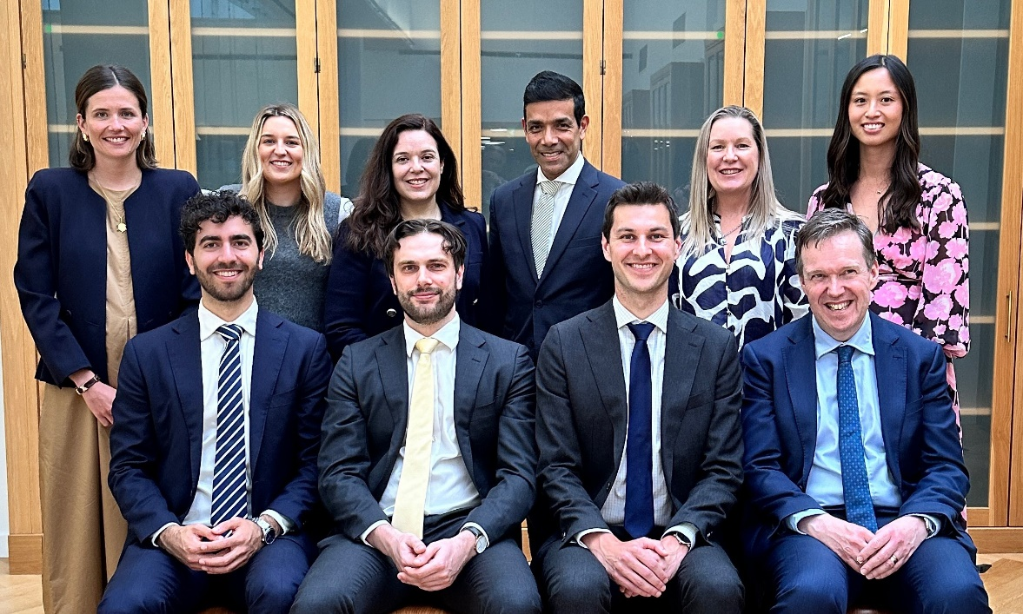
The President with the executive: (L to R Top) Melanie Gilbert, Claudia McCulloch, Tania Mattei, Alex Cartel, Rebecca Andrewartha, Katrina Fong (L to R Bottom) Jordan Osrin, Daniel Lucanus, Andrew Bubniw, Allan Bulman

Office
The Panel is co-located with the Department of the Treasury’s Melbourne office at Level 16, 530 Collins Street.

Appointment of Panel members
Table 2: Appointment of Panel members during 2024–25
Reappointments (14) | Appointments (4) | Terms completed (4)
Mr Alex Cartel (President)  Mr Kelvin Barry  Mr Michael Borsky KC  Mr Constantine Boulougouris  Mr James Burchnall  Mr Alberto Colla  Mr Bruce Cowley  Ms Chelsey Drake  Ms Marissa Freund  Mr Timothy Longstaff  Mr John McGlue  Mr Bruce McLennan  Mrs Deborah Page AM  Ms Philippa Stone | Ms Kellie Benda  Mr Costas Condoleon  Ms Tonianne Dwyer  Ms Susan Forrester AM | Mr Robin Bishop  Ms Elizabeth Hallett  Ms Denise McComish  Ms Kerry Morrow

Members are appointed on a part-time basis, usually for 3 years, by the Governor-General on the nomination of the Minister. State and Territory Ministers may submit nominations to the Minister. Members are nominated on the basis of their knowledge and experience in one or more of the fields of business, administration of companies, financial markets, financial products and financial services, law, economics and accounting. A mix of expertise, geographical representation and gender representation is also considered.
Chart 2: Panel members by profession at 30 June 2025
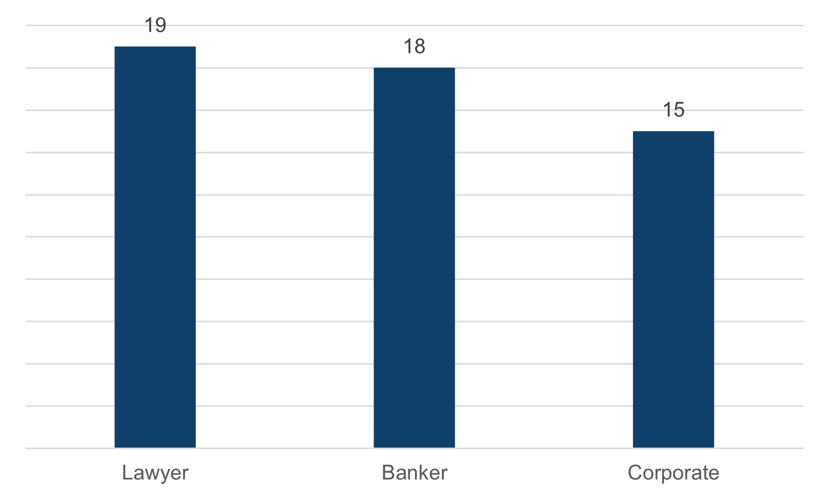

Chart 3: Panel members by location at 30 June 2025
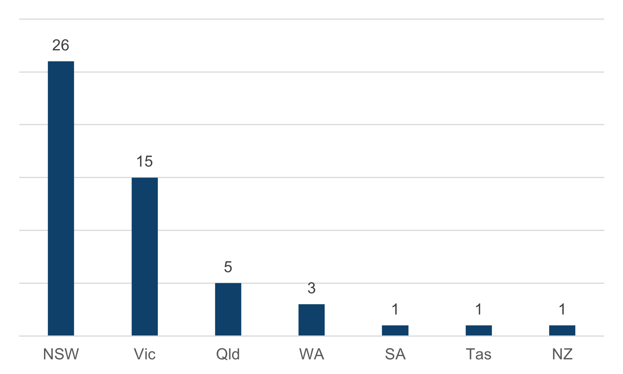
Chart 4: Panel members by gender at 30 June 2025
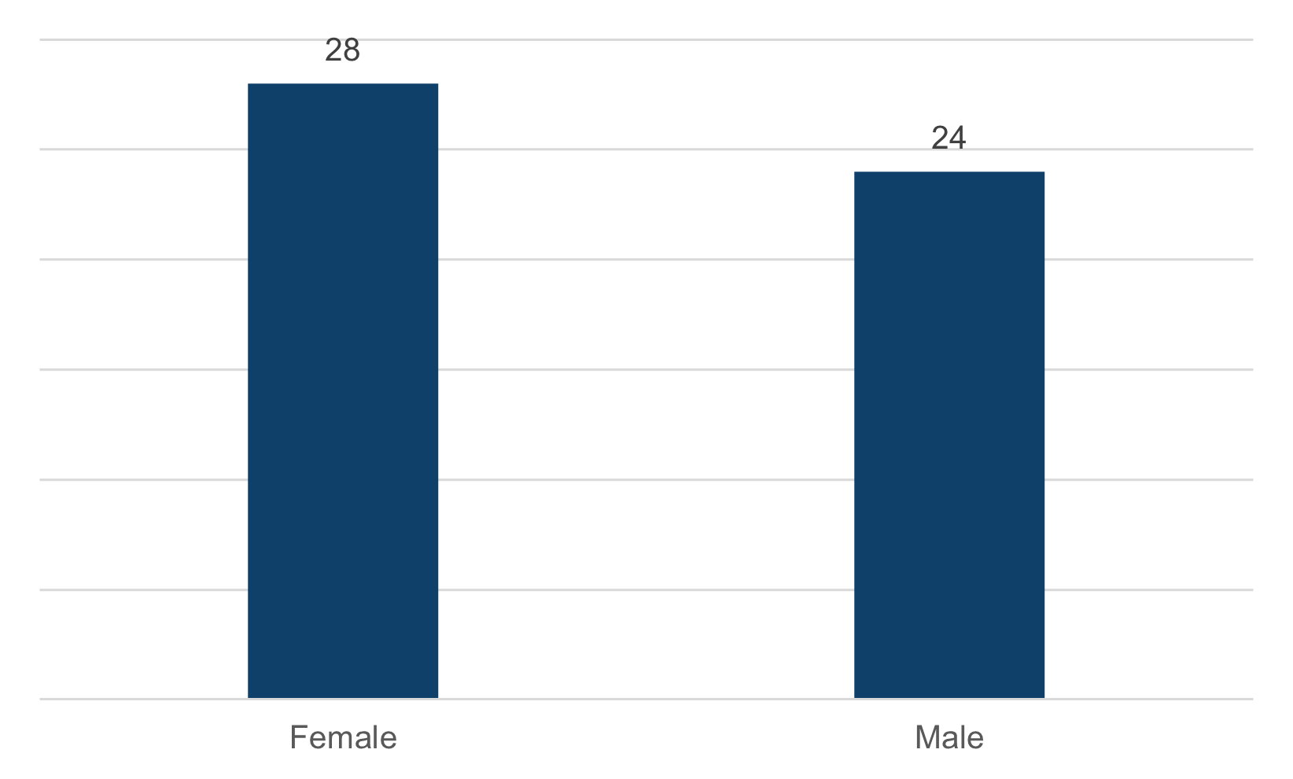

Members’ biographies
Alex Cartel (President) – Managing Director and Head of Global Advisory, Australia, Rothschild & Co. Member since 2015.
Yasmin Allen AM – Chairman of Digital Skills Organisation and Tiimely. Non-executive director of QBE Insurance, Santos Limited. Member since 2017.
Kelvin Barry – Managing Director and Co-Head of Advisory and Capital Markets, Australasia at UBS. Member since 2016.
Kellie Benda – Non-executive director of the National Reconstruction Fund Corporation, Aurora Energy, Geoscape Australia, Grains Research and Development Corporation, Brightwater Care Group; and non-executive member of the Foreign Investment Review Board. Member since 2025.
Carl Blanchard – Chair of New Zealand Takeovers Panel and Partner at PwC New Zealand. Member since 2022.
Michael Borsky KC – Barrister. Member since 2019.
Constantine Boulougouris – Partner at MinterEllison. Member since 2022.
James Burchnall – Director at Kain Lawyers. Member since 2022.
Stephanie Charles – Deal Partner and Head of Capital Markets at BGH Capital. Member since 2015.
Alberto Colla – Partner at MinterEllison. Member since 2022.
Costas Condoleon – Partner at Gilbert + Tobin. Member since 2025.
Bruce Cowley – Non-executive director of Australian Retirement Trust, Sunshine Coast Hospital and Health Service, South Bank Corporation, Klarna Australia Pty Ltd, Counter Ruck Pte Ltd (Fijian Drua Rugby); and Chair of the Queensland Trust for Nature. Adjunct Professor at University of Queensland. Member since 2016.
Kierin Deeming – Managing Director and Head of M&A Australia and New Zealand at J.P. Morgan. Member since 2024.
Chelsey Drake – Chair of Allens. Member since 2016.
Tonianne Dwyer – Non-executive director of Dyno Nobel Limited, AUB Group Limited, Growthpoint Properties Australia Limited, ALS Limited, General Sir John Monash Foundation. Deputy Chancellor of University of Queensland. Member since 2025.
Teresa Dyson – Non-executive director of Seven West Media Ltd, Shine Justice Ltd, Invest Gold Coast Pty Ltd. Member of Gold Coast Hospital and Health Board. Member since 2018.
Katrina Efthim – Managing Director and Head of Consumer, Retail and Healthcare Advisory (Australia and New Zealand) at Citigroup. Member since 2024.
Sylvia Falzon – Non-executive director of Suncorp Group Limited, Premier Investments Limited. Chairman of Cabrini Australia Limited. Member since 2023.
Joseph Fayyad – Australia Chief Executive Officer for Bank of America. Member since 2023.
Susan Forrester AM – Non-executive director at Iress Limited, South Bank Corporation. Chair of Jumbo Interactive Limited, and Wallbridge Gilbert Aztec. Member since 2025.
Marissa Freund – Managing Director and Head of Mergers & Acquisitions (Australia & New Zealand) at Goldman Sachs. Member since 2019.
Jonathan Gidney – Non-executive director at FNZ Group APAC, Cettire Limited. Director at El Calamar Capital. Senior Advisor at Wilsons Advisory. Member since 2024.
Louise Higgins – Executive General Manager Strategy, Transformation and Data, Retail at Australia & New Zealand Banking Group Limited. Non-executive director of Enero Group and Rugby Australia. Member since 2023.
Ruth Higgins SC – Barrister. Member since 2023.
Michelle Jablko – Chief Executive Officer of Transurban Limited. Member since 2014.
Christian Johnston – Advisory Director at Goldman Sachs, Australia & New Zealand. Member since 2014.
Kristen Jung – Global Head of Legal and Executive Director at Macquarie Capital. Member since 2020.
Marina Kelman – Executive for Corporate Finance – Investor Relations, Treasury, M&A, Energy and Subsidiaries at Telstra. Chair of Audit and Risk Committee at Baker Heart and Diabetes Institute. Member since 2021.
Jeremy Leibler – Partner at Arnold Bloch Leibler. Non-executive director of Thorney Technologies Limited. Member since 2015.
Michael Lishman – PhD student at Monash University. Formerly Partner at Jones Day, Clifford Chance, King & Wood Mallesons. Member since 2020.
Timothy Longstaff – Non-executive director of Aurizon Holdings Limited, Aurizon Network Pty Ltd, Ingham’s Group Limited, Nine Entertainment Co. Holdings Limited, Perenti Limited, and The George Institute for Global Health. Member since 2022.
Sandy Mak – Partner and Head of Corporate and M&A at Corrs Chambers Westgarth. Member since 2021.
Rebecca Maslen-Stannage – Global Chair and Senior Partner at Herbert Smith Freehills Kramer. Member since 2017.
John McGlue – Principal at Castle Gates Australia. Member since 2019.
Bruce McLennan – Managing Director and Co-Head of Advisory at Gresham Advisory Partners. Member since 2016.
Rory Moriarty – Partner at Clayton Utz. Member since 2018.
Emma-Jane Newton – Head of Investment Banking Coverage & Advisory for Australia and New Zealand at Deutsche Bank. Chair of Sydney Dance Company. Member since 2023.
Diana Nicholson – Partner and Financial Services Sector Leader at King & Wood Mallesons. Director of Care Australia Limited. Chair of Melbourne Girls Grammar School Council. Member since 2017.
Deborah Page AM – Non-executive director of Brickworks Limited, Growthpoint Properties Australia, The Star Entertainment Group Limited, and Magellan Financial Group Limited. Member since 2022.
Reeny Paraskeva – Managing Director and Head of General Industrials at Jarden. Member since 2024.
Neil Pathak – Partner and Co-Head of M&A for Australia at Ashurst. Senior Fellow at Melbourne Law School. Member since 2017.
Richard Phillips – Managing Director and Chairman of Greenhill Australia. Member since 2024.
Karen Phin – Non-executive director of Omni Bridgeway Limited, ARB Corporation Ltd, B.B.M. Ltd. Member since 2015.
Sarah Rennie – Co-CEO of Jarden. Member since 2015.
John Sheahan KC – Barrister. Member 2014–2020 and since 2021.
Christopher Stavrianou – Managing Partner at Poynton Stavrianou. Member since 2024.
James Stewart – Partner at Pinsent Masons. Member since 2020.
Philippa Stone – Joint Global Head of Capital Markets and Partner at Herbert Smith Freehills Kramer. Deputy Chair of the Centre for Independent Studies. Member of Asia Society Advisory Council. Member since 2019.
Erin Tinker – Founding Partner at Barrenjoey. Member since 2023.
Kate Towey – General Counsel at Qantas. Member since 2023.
Georgina Varley – Managing Director at Adamantem Capital. Non-executive director of Adamantem portfolio companies: Climate Friendly, Retail Zoo, and Mason Stevens. Member since 2024.
Nicola Wakefield Evans AM – Non-executive director of Viva Energy Group Limited, Sonic Healthcare Limited, Clean Energy Finance Corporation, and Goodes O’Loughlin Foundation Limited. Chair of MetLife Insurance Limited and MetLife General Insurance Limited. Guardian of the Future Fund. Member since 2015.

Part 3 – The Work of the Panel

Matters
The Panel resolves matters as quickly and as informally as a proper consideration of the issues permits. Timeliness remains one of the key performance indicators for the Panel. Proceedings are generally conducted in private because of commercial sensitivity and time constraints. The Panel has the power to invite or accept submissions from any person and to call for persons to make submissions.
The following chart maps the Panel’s usual process in relation to applications for declarations of unacceptable circumstances.
Chart 5: The Panel’s process for applications for declarations of unacceptable circumstances
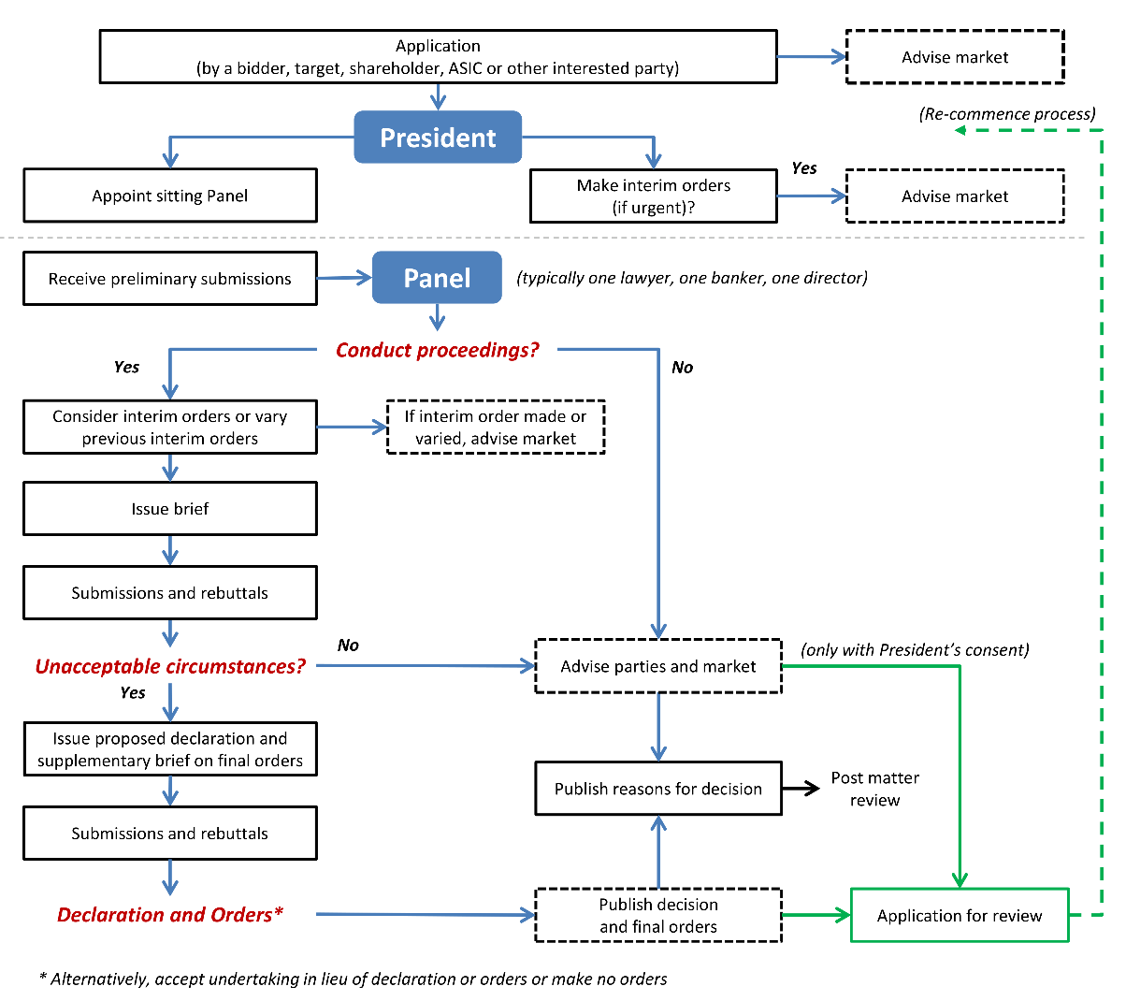

The Panel usually receives material voluntarily from parties in response to a Panel brief. The Panel has the power to convene a conference and summon witnesses to give evidence and provide documents. During the 2024–2025 financial year the Panel did not conduct any conferences or summons any witnesses.
Further description of the Panel’s processes can be found on its website.
Appendix 3 lists the applications in the current period (35 in total). Table 3 groups the applications by outcome and Table 4 shows the time frame to decision. Table 5 groups applications by subject matter.
Table 3: Outcome of applications received by the Panel, 2024–25
Form of resolution | Number of matters | Comments
Declaration and orders | 3 | Circumstances are unacceptable and may be remedied with orders
Declaration and undertakings | 1 | Potential substitute for orders
Conduct proceedings, no declaration, undertaking/  action by party | 0 | Panel decides to conduct proceedings, but does not find any unacceptable circumstances after a party provides an undertaking or takes an action that resolves any potential unacceptable circumstances
Conduct proceedings, no declaration | 7 | Panel decides to conduct proceedings, but does not find any unacceptable circumstances
Decline to conduct proceedings, undertaking/  action by party | 1 | Panel decides to not conduct proceedings after a party provides an undertaking or takes an action that resolves any potential unacceptable circumstances
Decline to conduct proceedings | 19 | Panel does not conduct proceedings, for example, because it did not think the circumstances complained of would be unacceptable, or there was not a sufficient basis for inquiring further
Proceedings withdrawn | 3 | Applicant withdraws (Panel consent is required)
Decline to make interim order, undertaking/action by party | 1 | For applications for interim orders only
Total | 35
Table 4: Time to decision by the Panel, 2024–25
Time to decision | Number of matters | Average days to decision
Up to 14 days | 17* | 10.0
15 days to 31 days | 11 | 18.8
32 days to 90 days | 7 | 48.4
Total | 35 | 20.5
* Including three withdrawn applications

Issues in applications
Table 5: Issues raised in applications, 2024–25
Issue | Number | Matters
Association/  breach of s606 | 12.5 | AIMS Property Securities Fund 04, Tissue Repair Ltd, AIMS Property Securities Fund 05R, Global Lithium Resources Limited, Keybridge Capital Limited 15 and Benjamin Hornigold Ltd 13, Global Lithium Resources Limited 02R, Vmoto Limited (in part), Keybridge Capital Limited (Administrator Appointed) 16 and Benjamin Hornigold Ltd 14 (in part), Vmoto Limited 02R (in part), Emu NL, Emu NL 02R, Mayfield Childcare Limited, Keybridge Capital Limited 20 (in part)
Rights issues and placements | 8.5 | Energy Resources of Australia Limited 04, Energy Resources of Australia Limited 05R, Alara Resources Limited, FBR Ltd, Yowie Group Ltd 04, Emu NL 03 (in part), FBR Ltd 02, Yowie Group Ltd 05, New World Resources Limited
Frustrating action | 2 | Keybridge Capital Limited (Administrator Appointed) 16 and Benjamin Hornigold Ltd 14 (in part), Keybridge Capital Limited 17 (in part), Keybridge Capital Limited 18R (in part)
Delisting | 3 | Vmoto Limited (in part), Vmoto Limited 02R (in part), Pact Group Holdings Ltd 02 and 03
Insider participation | 1.5 | Keybridge Capital Limited 17 (in part), Keybridge Capital Limited 18R (in part), Keybridge Capital Limited 20 (in part)
Shareholder intention statements | 1.5 | Namoi Cotton Limited (in part), Dropsuite Limited
Others | 6 | Ringers Western Limited 03 (selective buy-back), Montu Group Pty Ltd (compulsory acquisition), Namoi Cotton Limited (in part, collateral benefits), Invest Blue Pty Ltd (avoidance of Chapter 6), Emu NL 03 (in part, conduct of meeting), Yowie Group Ltd 06 and Keybridge Capital Limited 19 (bidder’s statement disclosure)
Total | 35
Note: The table captures the main basis for an application (or if there are two they are shown as ‘in part’ and contribute to half scores) in the view of the Panel executive.

Ensuring consistency
The Panel holds meetings of all its members around three times each year. These sessions are a valuable opportunity for them to get together and discuss past proceedings, policy issues and market developments.
Panel members’ firms host these meetings, as well as allow members time to attend, and the Panel appreciates this support.
The executive has issued an index of Panel decisions covering 1 March 2000 to 30 June 2025.

Guidance
The Panel publishes Guidance Notes to assist the market in relation to takeovers matters and to assist Panel members to make consistent decisions.
Guidance Notes are generally developed by sub-committees of Panel members. Sometimes other market participants are invited to be sub-committee members. Appendix 2 lists sub-committee members. The Panel thanks them for their contributions.

Consultation
In addition to post matter reviews (see below), the Panel undertakes public consultation in relation to policy or procedural issues. The Panel may approach interest groups if they are likely to be materially affected or may provide specialised input. The Panel publishes all submissions. The Panel also publishes a response to submissions addressing the main comments received and the reasons for adopting or rejecting them. For more information, see takeovers.gov.au/consultations.
In the current period the Panel published no consultation papers.

Legislation
The Panel operates under the Corporations Act and ASIC Act.

Judicial review
There were no judicial reviews of the Panel’s decisions in the current period.

Part 4 – Performance Reporting

Matter reviews
Panel decisions are discussed at Panel days. The Panel also invites parties to participate in a post matter review after a matter has concluded. Three post matter reviews were held in 2024–25.

Industry liaison
The Panel executive liaises with the major regulators in the takeovers area in Australia and overseas. Liaison with Australian regulators (ASIC, with which the Panel executive has an MOU; ASX; and FIRB) ensures that the Panel has effective working relations and its regulatory role fits appropriately with theirs. The Panel executive holds regular liaison meetings with ASIC staff to discuss policy developments and recent issues.
The Panel executive contributes to the Asia Pacific Takeovers Regulators Forum.
The Panel also maintains contact with organisations such as the Business Law Section of the Law Council of Australia. Panel members and the executive also attend and speak at industry meetings, education sessions and seminars.

Referrals to ASIC
ASIC is involved in every application. Matters might be specifically referred to ASIC because:
- a sitting Panel considers that ASIC should look into aspects of the application that might give rise to concerns under the Corporations Act generally
- the Panel wants ASIC to consider whether to make an application.
There was one referral made during the current period.

Website
The Panel uses its website (takeovers.gov.au) to maintain a market presence, inform, invite contact, publish documents and undertake policy consultation.

Announcements and media releases
Panel decisions are available through the Panel’s website or RSS feed.
If the entity involved in a Panel matter is listed, the Panel’s media releases in relation to that matter are also made available on the ASX website or the relevant Australian securities exchange.

Corporate governance

Planning and review
The executive holds regular operational review meetings with the President and Treasury.
Executive staff performance is reviewed as part of Treasury’s performance appraisal program.
The APS Values and Code of Conduct apply to the executive and, in certain circumstances, Panel members.

Fraud control
The Panel is covered by Treasury’s Fraud and Corruption Control Plan 2024–26.

Risk management
The Panel maintains a risk register and major risks are reviewed monthly.

Outcome and output information

Organisational budget
The Panel’s funding is included in Treasury‘s budget. The Panel relies on Treasury’s administrative infrastructure and processes.

Treasury accountability
The Chief Executive provides monthly reports on financial and operational issues to the President and to the Deputy Secretary, Markets Group in Treasury.

Outcome and program structure
In the current period, the Panel’s functions contributed to Treasury’s Outcome 1: ‘Supporting and implementing informed decisions on policies for the good of the Australian people, including for achieving strong, sustainable economic growth, through the provision of advice to Treasury Ministers and the efficient administration of Treasury’s functions.’
The Panel’s outputs contribute to Treasury’s Program 1.1: Department of the Treasury.
Table 6: Summary resource statement
 | Actual budget allocation | Expenses | Balance remaining
 | 2024–25  ($’000) | 2024–25  ($’000) | 2024–25  ($’000)
Revenue
Revenue (Department of the Treasury budget allocation and section 74 relevant agency receipts) | 2,701 | 2,540 | 161
Total resourcing | 2,701 | 2,540 | 161
 |  | 2024–25 | 2025–26
Average staffing levels (number) |  | 7.3 | 7.6

Treasury outcome
The Panel contributes to Treasury’s outcome through:
- timely, clear and consistent decisions in line with market practice
- guidance to assist market participants regarding takeover aspects of the Corporations Act and ASIC Act (including seeking public consultation from market participants)
- procedural rules for fair, timely and cost-effective resolution of disputes.

Financial information

Schedule of Revenues and Expenditures
Table 7: Income statement (Showing Net Cost of Services) (unaudited) for the period ended 30 June 2025
NET COST OF SERVICES | $
Employee expenses
Wages and salaries | 1,417,772
Superannuation | 221,458
Members’ annual retainer and sitting fees | 618,611
Total employee expenses | 2,257,841
Operating expenses
Consultants | 15,148
Contractors | 47,089
Travel | 103,805
Legal | 12,222
Publications and subscriptions | 28,365
General Office | 38,485
Conferences and training | 36,800
Total operating expenses | 281,914
Total expenses incurred to 30 June 2025 | 2,539,754
Own source income | –
Net cost of services | (2,539,754)
Revenue (Department of the Treasury budget allocation) | 2,701,000
Surplus/(Deficit) | 161,246

Audit
The Panel is a division of the Treasury. Treasury’s financial statements are subject to audit by the ANAO. The Panel’s operations are also subject to review under Treasury’s internal audit program.

Notes to the Schedule of Revenues and Expenditures

Statement of accounting policies
The significant accounting policies that have been adopted in the preparation of this financial information are:

Basis of preparation
This special purpose financial information is required under section 183 of the ASIC Act.
The financial information has been prepared on an accrual basis and are presented in Australian dollars.

Revenue
Revenue represents the Panel’s budget allocation of Treasury’s appropriation (revenue from Government) for the financial year. Other revenue represents retained revenue receipts under section 74 of the Public Governance, Performance and Accountability Act 2013.

Expenses
Expenses are recognised on an accruals basis and only relate to the direct costs of the Panel.

Surplus
The surplus represents the Panel’s underspend against its budget allocation for the 2024–‍25 financial year. Surpluses and deficits recorded by the Panel are consolidated into Treasury’s financial statements.

Salaries and members’ annual retainer and sitting fees
Salaries and member sitting fees are recognised as they occur.
Salaries for the financial year include payments to firms for secondees’ services. The payments are treated as payments for wages and salaries, not consultants.

GST
Revenue and expenses are recognised net of goods and services tax.

Part 5 – Management and Accountability

External scrutiny
Panel decisions in relation to unacceptable circumstances and orders are subject to internal review by another Panel. All Panel decisions are subject to judicial review. However, most reviews of Panel decisions end with the review Panel process.
See Table 14 for a breakdown of Panel review proceedings.

Government scrutiny
The Panel was not subject to any reports by the ANAO in 2024–25.
The Panel attends hearings of the Senate Standing Committee on Economics and the Parliamentary Joint Committee on Corporations and Financial Services as required.

Ombudsman
The Panel was not aware of any reports by the Commonwealth Ombudsman in 2024–25 in relation to the Panel.

Management of human resources

Staffing
At 30 June 2025, the executive consisted of eight permanent staff (one on long term leave) and one legal secondee. Permanent staff are employed under the Public Service Act 1999 (Cth).

Table 8: Operative staff by classification and gender
Classification | Full time |  | Part time |  | Total
 | Male | Female | Male | Female
APS5 | 1* | 1 | 0 | 0 | 2
APS6 | 0 | 1 | 0 | 0 | 1
EL1 | 0 | 0 | 0 | 0 | 0
EL2 | 1 | 1† | 0 | 1 | 3
SEB1 | 1 | 0 | 0 | 0 | 1
SEB2 | 0 | 1 | 0 | 0 | 1
Total | 3 | 4 | 0 | 1 | 8
* On temporary transfer
† On long term leave
Note: Acronyms in the table can be found in Appendix 4.

Secondments
The small number of permanent staff on the executive is supplemented by secondees from law firms, other professional firms or ASIC. The Panel executive organises functions and meetings with former staff and secondees, in part for succession planning purposes.

Staff development
The Panel seeks to ensure that its staff develop their core skills. Legal staff are encouraged to attend legal and commercial training and conferences. Non-legal staff are encouraged to attend training, including in relation to management and administration.

Executive remuneration
As Panel executive staff are Treasury employees, information about executive remuneration can be found in Treasury’s Annual Report (Part 3: Management and Accountability).
The Panel did not make any specific performance payments or bonus payments.

Remuneration for non-SES
The Treasury Enterprise Agreement 2024–27 determines salary rates for non-SES staff. The new agreement commenced on 22 January 2024. Details and statistics on non-SES remuneration are included in Treasury’s Annual Report (Part 3: Management and Accountability).

Workplace diversity
The Panel values diversity and benefits from Treasury’s Inclusion and Diversity Strategy 2023–28. Details and statistics on workplace diversity are included in Treasury’s Annual Report (Part 3: Management and Accountability).

Industrial democracy
Panel staff utilise Treasury’s Performance Development System and Integrated Leadership System. Treasury’s Workplace Relations Committee deals with industrial democracy issues.

Work health and safety
Panel staff have the benefit of Treasury‘s Work Health and Safety Management System. Services provided to the Panel for the year included flu injections for the Panel executive. There were no reported accidents or dangerous occurrences during the year.
The Panel utilises Treasury’s Employee Assistance Program, an external and confidential counselling service for Treasury staff and their families.

Disability reporting mechanism
Australia’s Disability Strategy 2021–2031 is the overarching framework for inclusive policies, programs and infrastructure that will support people with disability to participate in all areas of Australian life. The Strategy sets out where practical changes will be made to improve the lives of people with disability in Australia. It acts to ensure the principles underpinning the United Nations Convention on the Rights of Persons with Disabilities are incorporated into Australia’s policies and programs that affect people with disability, their families and carers. All levels of government have committed to deliver more comprehensive and visible reporting under the Strategy. A range of reports on progress of the Strategy’s actions and outcome areas will be published and available at disabilitygateway.gov.au/ads.
Disability reporting is included in the Australian Public Service Commission’s State of the Service reports and APS Employment Data Releases. These reports are available at apsc.gov.au.

Purchasing
The Panel follows Treasury’s procurement framework to ensure that it undertakes competitive and non-discriminatory tendering and quoting processes which are designed to result in value for money.
All proposed procurements valued at $10,000 or more were reviewed by Treasury’s Procurement Team.
During 2024–25 the Panel entered into two contracts that exceeded $10,000. These related to a secondment and events management.

Consultants
The Panel did not engage any consultants during 2024–25.

Small business
The Panel supports small business participation in the Commonwealth Government procurement market. Small and Medium Enterprises (SME) and Small Enterprise participation statistics are available on the Department of Finance’s website (finance.gov.au).

Discretionary grants
The Panel did not make any discretionary grants in 2024–25.

Advertising and market research
The Panel did not undertake any advertising or market research in 2024–25.

Environmental performance
The Panel follows Treasury’s Environmental Management Plan. Details on actions taken in relation to ecologically sustainable development and environmental performance are included in Treasury’s Annual Report (Part 5: Appendices – Ecologically sustainable development and environmental performance).

Freedom of information
Entities subject to the Freedom of Information Act 1982 (Cth) (FOI Act) are required to publish information to the public as part of the Information Publication Scheme (IPS). This requirement is in Part II of the FOI Act and has replaced the former requirement to publish a section 8 statement in an annual report. Each agency must display on its website a plan showing what information it publishes in accordance with the IPS requirements. The Panel’s IPS Agency Plan can be found on its website.

Impact analysis
The Panel did not submit any Impact Analyses in 2024–25.

Appendix 1 – Panel members
Table 9: Members of the Panel at 30 June 2025
Mr Alex Cartel (President) | Ms Kristen Jung
Ms Yasmin Allen AM | Ms Marina Kelman
Mr Kelvin Barry | Mr Jeremy Leibler
Ms Kellie Benda | Mr Michael Lishman
Mr Carl Blanchard | Mr Timothy Longstaff
Mr Michael Borsky KC | Ms Sandy Mak
Mr Constantine Boulougouris | Ms Rebecca Maslen-Stannage
Mr James Burchnall | Mr John McGlue
Ms Stephanie Charles | Mr Bruce McLennan
Mr Alberto Colla | Mr Rory Moriarty
Mr Costas Condoleon | Ms Emma-Jane Newton
Mr Bruce Cowley | Ms Diana Nicholson
Mr Kierin Deeming | Mrs Deborah Page AM
Ms Chelsey Drake | Ms Reeny Paraskeva
Ms Tonianne Dwyer | Mr Neil Pathak
Ms Teresa Dyson | Mr Richard Phillips
Ms Katrina Efthim | Ms Karen Phin
Ms Sylvia Falzon | Ms Sarah Rennie
Mr Joseph Fayyad | Mr John Sheahan KC
Ms Susan Forrester AM | Mr Christopher Stavrianou
Ms Marissa Freund | Mr James Stewart
Mr Jonathan Gidney | Ms Philippa Stone
Ms Louise Higgins | Ms Erin Tinker
Dr Ruth Higgins SC | Ms Kate Towey
Ms Michelle Jablko | Ms Georgina Varley
Mr Christian Johnston | Ms Nicola Wakefield Evans AM

Table 10: Members appointed to the Panel in 2024–25
Ms Kellie Benda | Ms Tonianne Dwyer
Mr Costas Condoleon | Ms Susan Forrester

Table 11: Members who ceased their membership of the Panel in 2024–25
Mr Robin Bishop | Ms Denise McComish
Ms Elizabeth Hallett | Ms Kerry Morrow

Appendix 2 – Sub-committee members
Table 12: Sub-committees-
Sub-committee | Panel members | External members
Improving Panel Processes with Parties | Mr Alex Cartel (President)
 | Ms Sylvia Falzon
 | Ms Marina Kelman
 | Mr Michael Lishman
 | Ms Rebecca Maslen-Stannage
 | Mr John McGlue
 | Mr Neil Pathak
 | Ms Karen Phin
 | Ms Erin Tinker
Equity Derivatives and Beneficial Ownership | Mr Alex Cartel (President)
 | Mr Kelvin Barry
 | Ms Sylvia Falzon
 | Ms Marissa Freund
 | Mr Jonathan Gidney
 | Mr Christian Johnston
 | Ms Kristen Jung
 | Ms Marina Kelman
 | Mr Jeremy Leibler
 | Ms Diana Nicholson
 | Ms Reeny Paraskeva
 | Ms Rebecca Maslen-Stannage
 | Mr James Stewart
 | Ms Philippa Stone
 | Ms Erin Tinker
Merger Reform | Mr Alex Cartel (President)
 | Ms Sylvia Falzon
 | Mr Jonathan Gidney
 | Ms Marina Kelman
 | Ms Rebecca Maslen-Stannage
 | Mr Rory Moriarty
 | Ms Diana Nicholson
 | Ms Nicola Wakefield Evans AM

Appendix 3 – Panel applications
Table 13: Applications received by the Panel in 2024–25
# | Matter no. | Section/s | Matter name | Decision | Application date | Decision date | Days to decision
1 | 2024/17 | 657A,D&E | AIMS Property Securities Fund 04 | Declined to conduct proceedings | 20/08/2024 | 28/08/2024 | 8
2 | 2024/18 | 657A,D&E | Tissue Repair Ltd | Declined to conduct proceedings | 28/08/2024 | 19/09/2024 | 22
3 | 2024/19 | 657EA | AIMS Property Securities Fund 05R | Declined to conduct proceedings | 29/08/2024 | 18/09/2024 | 20
4 | 2024/20 | 657A,D&E | Ringers Western Limited 03 | Proceedings withdrawn | 30/08/2024 | 04/09/2024 | 5
5 | 2024/21 | 657A,D&E | Energy Resources of Australia Limited 04 | Declined to conduct proceedings | 04/09/2024 | 24/09/2024 | 20
6 | 2024/22 | 657A,D&E | Montu Group Pty Ltd | Declaration and undertakings | 06/09/2024 | 23/10/2024 | 47
7 | 2024/23 | 657A,D&E | Namoi Cotton Limited | Proceedings withdrawn | 18/09/2024 | 16/10/2024 | 14
8 | 2024/24 | 657EA | Energy Resources of Australia Limited 05R | Conduct proceedings, no declaration | 26/09/2024 | 14/10/2024 | 18
9 | 2024/25 | 657A,D&E | Alara Resources Limited | Declaration and orders | 20/11/2024 | 13/01/2025 | 54
Table 13: Applications received by the Panel in 2024–25 (continued)
# | Matter no. | Section/s | Matter name | Decision | Application date | Decision date | Days to decision
10 | 2025/01 | 657A&D | Global Lithium Resources Limited | Declined to conduct proceedings | 09/01/2025 | 23/01/2025 | 14
11 | 2025/02 | 657A,D&E | Keybridge Capital Limited 15 | Declined to conduct proceedings | 21/01/2025 | 31/01/2025 | 10
12 | 2025/03 | 657A,D&E | Benjamin Hornigold Ltd 13 | Declined to conduct proceedings | 21/01/2025 | 31/01/2025 | 10
13 | 2025/04 | 657EA | Global Lithium Resources Limited 02R | Declined to conduct proceedings | 27/01/2025 | 11/02/2025 | 15
14 | 2025/05 | 657A&D | Invest Blue Pty Ltd | Declined to conduct proceedings | 17/02/2025 | 25/02/2025 | 8
15 | 2025/06 | 657A,D&E | Vmoto Limited | Declined to conduct proceedings | 17/02/2025 | 28/02/2025 | 11
16 | 2025/07 | 657A,D&E | Keybridge Capital Limited (Administrator Appointed) 16 | Declined to conduct proceedings | 21/02/2025 | 11/03/2025 | 18
17 | 2025/08 | 657A,D&E | Benjamin Hornigold Ltd 14 | Declined to conduct proceedings | 21/02/2025 | 11/03/2025 | 18
18 | 2025/09 | 657EA | Vmoto Limited 02R | Declined to conduct proceedings | 02/03/2025 | 17/03/2025 | 15
19 | 2025/10 | 657A,D&E | Dropsuite Limited | Declaration and orders | 17/03/2025 | 04/04/2025 | 18
20 | 2025/11 | 657A&D | Emu NL | Declined to conduct proceedings | 03/04/2025 | 16/04/2025 | 13
21 | 2025/12 | 657EA | Emu NL 02R | Declined to conduct proceedings | 22/04/2025 | 05/05/2025 | 13
Table 13: Applications received by the Panel in 2024–25 (continued)
# | Matter no. | Section/s | Matter name | Decision | Application date | Decision date | Days to decision
22 | 2025/13 | 657A&D | FBR Ltd | Proceedings withdrawn | 04/05/2025 | 13/05/2025 | 9
23 | 2025/14 | 657A,D&E | Pact Group Holdings Ltd 02 | Declined to conduct proceedings | 08/05/2025 | 21/05/2025 | 13
24 | 2025/15 | 657A,D&E | Pact Group Holdings Ltd 03 | Declined to conduct proceedings | 08/05/2025 | 21/05/2025 | 13
25 | 2025/16 | 657A,D&E | Yowie Group Ltd 04 | Conduct proceedings, no declaration | 13/05/2025 | 29/07/2025 | 69
26 | 2025/17 | 657A,D&E | Emu NL 03 | Declaration and orders | 16/05/2025 | 10/07/2025 | 55
27 | 2025/18 | 657A&D | FBR Limited 02 | Declined to conduct proceedings | 18/05/2025 | 28/05/2025 | 10
28 | 2025/19 | 657A,D&E | Keybridge Capital Limited 17 | Conduct proceedings, no declaration | 23/05/2025 | 13/06/2025 | 21
29 | 2025/20 | 657A,D&E | Mayfield Childcare Limited | Conduct proceedings, no declaration | 03/06/2025 | 25/06/2025 | 22
30 | 2025/21 | 657A,D&E | Yowie Group Ltd 05 | Conduct proceedings, no declaration | 03/06/2025 | 29/07/2025 | 48³⁷
31 | 2025/22 | 657EA | Keybridge Capital Limited 18R | Declined to conduct proceedings | 17/06/2025 | 26/06/2025 | 9
32 | 2025/23 | 657A,D&E | Yowie Group Ltd 06 | Conduct proceedings, no declaration | 17/06/2025 | 29/07/2025 | 33
Table 13: Applications received by the Panel in 2024–25 (continued)
# | Matter no. | Section/s | Matter name | Decision | Application date | Decision date | Days to decision
33 | 2025/24 | 657A,D&E | Keybridge Capital Limited 19 | Conduct proceedings, no declaration | 17/06/2025 | 29/07/2025 | 33³⁸
34 | 2025/25 | 657E | New World Resources Limited | Decline to make interim order, undertaking/ action by party | 19/06/2025 | 19/06/2025 | 0
35 | 2025/26 | 657A,D&E | Keybridge Capital Limited 20 | Declined to conduct proceedings | 26/06/2025 | 10/07/2025 | 14

Table 14: Outcomes of review applications received by the Panel in 2024–25
# | Matter No. | Review matter name | Matter reviewed | Review outcome
1 | 2024/19 | AIMS Property Securities Fund 05R | AIMS Property Securities Fund 04 | Affirmed Panel decision
2 | 2024/24 | Energy Resources of Australia Limited 05R | Energy Resources of Australia Limited 04 | Affirmed Panel decision
3 | 2025/04 | Global Lithium Resources Limited 02R | Global Lithium Resources Limited | Affirmed Panel decision
4 | 2025/09 | Vmoto Limited 02R | Vmoto Limited | Affirmed Panel decision
5 | 2025/12 | Emu NL 02R | Emu NL | Affirmed Panel decision
6 | 2025/22 | Keybridge Capital Limited 18R | Keybridge Capital Limited 17 | Affirmed Panel decision

Appendix 4 – Abbreviations and acronyms
AICD | Australian Institute of Company Directors
ANAO | Australian National Audit Office
APS | Australian Public Service
ASIC | Australian Securities and Investments Commission
ASX | ASX Limited
EL | Executive Level
FIRB | Foreign Investment Review Board
M&A | Mergers and Acquisitions
MOU | Memorandum of Understanding
SEB | Senior Executive Band
SES | Senior Executive Service
Treasury | Commonwealth Department of the Treasury

Index

A
Acting Presidents 10
Applications 6, 20, 21, 40, 41, 42, 43
Australian Securities and Investments Commission Act 2001 (Cth) 22
C
Consultants 34
Corporate governance 26
Corporations Act 2001 (Cth) 1, 22
D
Decision 6, 21
Disability reporting mechanism 33
Discretionary grants 34
E
Enquiries 2
Environmental performance 34
Executive 10, 31
External scrutiny 31
F
Financial information 28
Freedom of information 35
G
Gender 14
Guidance 7, 22
I
Impact Analyses 35
Industrial democracy 33
J
Judicial review 23
L
Legislation 22
M
Management and accountability 31
Management of human resources 31
Matters 6, 19
O
Organisational structure 9
Outcome and output information 26
P
Panel members 12, 15, 36
President 3, 9
Purchasing 34
R
Remuneration 32
Review of a Panel decision 8, 44
Review of ASIC decisions 7, 8
S
Secondments 32
Small business 34
Staff development 32
Staffing 31
Sub-committee members 38
T
Treasury 26, 27, 28, 33
W
Website 26
Work health and safety 33
Workplace diversity 33

Section 172(4) of the ASIC Act.
Paragraph [7.16] of the Explanatory Memorandum for the Corporate Law Economic Reform Program Bill 1998 (Cth).
Section 659AA of the Corporations Act.
Dropsuite Limited [2025] ATP 10 at [77].
For example, if it does not clearly set out the relevant circumstances or the key reasons as to why those circumstances are alleged to be unacceptable: see rule 12 of the Panel’s Procedural Rules.
[2001] ATP 17 at [55].
Treasury Laws Amendment (Mergers and Acquisitions Reform) Bill 2024.
Treasury Laws Amendment (Enhanced Disclosure of Ownership of Listed Entities) Bill 2024 (Exposure Draft).
See regulation 18 of the ASIC Regulations.
For applications received during the financial year.
For applications received during the financial year. A breakdown of days from application and decision is in Table 4: Time to decision by the Panel, 2024–25.
For matters decided during the financial year. This is a change from previous annual reports, in which this statistic was calculated for applications received during the financial year.
The equivalent statistic for the 2023–24 financial year was initially published as 44.1 calendar days but has since been revised (to 46.6 calendar days) because the reasons for the sitting Panel’s decision in Pacific Smiles Group Limited were finalised after the publication of the 2023–24 annual report.
Section 657A and, if a declaration is made, orders under section 657D.
Under section 655A and, during a takeover bid, section 673 (see section 656A).
Unless otherwise indicated, all statutory references are to the Corporations Act 2001 (Cth) and all terms used in Chapters 6 or 6C have the meaning given in the relevant Chapter (as modified by ASIC).
Section 656A(3).
Section 9. However, it cannot make an order directing a person to comply with a requirement of Chapters 6–6C.
Only with consent of the President if the initial Panel did not make a declaration or orders. See generally section 657EA.
Section 658C.
Section 195 of the ASIC Act.
Section 657EB.
Section 173 of the ASIC Act.
Sections 182(1)(a) and (b) of the ASIC Act.
Section 172 of the ASIC Act.
Section 172(4A) of the ASIC Act.
Regulations 35 to 41 of the ASIC Regulations.
Section 192 of the ASIC Act.
Section 201A of the ASIC Act.
In 2024–25, the Panel held Panel days in August 2024, November 2024, and May 2025.
Regulation 18 of the ASIC Regulations.
Section 657EA. A decision that is not a decision to make a declaration, an interim order or a final order can only be reviewed under this section with the President’s consent.
Section 75(v) of the Constitution, the Judiciary Act 1903 and the Administrative Decisions (Judicial Review) Act 1977. See page 23 for details about current judicial reviews of Panel decisions.
The Panel also engaged one senior lawyer as a casual employee and another senior lawyer as a contractor for part of the financial year.
No employees identified themselves as Indigenous at 30 June 2025.
Under sections 657C and 657EA. The Panel also received two applications seeking the President’s consent to a review of a Panel decision (in Tissue Repair Ltd and Invest Blue Pty Ltd) and two applications to vary final orders (in Montu Group Pty Ltd and Southern Cross Media Group Limited 02R and 03R).
Not counting a period of 8 days during which the proceedings were deferred under regulation 16(1)(j) of the ASIC Regulations.
Not counting a period of 9 days during which the proceedings were deferred under regulation 16(1)(j) of the ASIC Regulations.

